



**MEDSCHEME**

**WHATSAPP BOT DEVELOPMENT**

PROJECT PROPOSAL

**Date:** **August 23rd, 20****22**

**Prepared by: Rameshbabu, SKEIN Technologies Private Limited, India**

Date: **August 23rd, 2022**

To:

Proposal for development of WhatsApp bot.

Greetings from SKEIN Technologies Private Limited

Thank you for giving us this opportunity to submit a proposal for developing the WhatsApp Bot for Medscheme International.

The best long-term sales strategy is to have as many happy customers as possible. In the competitive online retail market, focusing on customer happiness is a core part of business. That’s why many e-Commerce companies, large and small, are so eager to get started with the WhatsApp Business solution

Based on our meetings and telephonic conversation with Dooshka and Khaleel, the requirement is to create a Insurance WhatsApp bot that can be used by Customers for getting various updates about their policy from the list of options already available in the WhatsApp bot an enhanced user experience.

We feel proud to take this opportunity and commit to deliver the project on time and give our best to make the project a great success.

Thanking You

Sincerely Yours

Ramesh Babu

Table of Content

1 Our Understanding 4

2 Solution Overview 4

2.1 Functionality and Flow: 5

3 Solution Architecture 9

3.1 Solution components overview 10

3.1.1 Twilio Api Services 10

3.1.2 Whatsapp Business Account 10

3.1.3 RASA Framework 10

3.1.4 Docker Containers 11

4 Project Scope & Delivery 12

4.1 Scope of Work 12

4.2 Project Activities 12

4.3 Key Assumptions 13

4.4 Project Exclusions 14

4.5 Project Estimates & delivery 14

4.6 Project Deliverables 14

5 Project scope Change Control Process 14

6 Project Responsibilities 15

6.1 Skein Responsibilities 15

6.2 Medscheme Responsibility 15

7 Commercials 16

7.1 Payment Terms for Phase 1: 16

7.1 Software/accounts to be procured by customer 16

7.2 Twilio API Costing estimates 16

# Our Understanding

The requirement is to create a Policy information sharing WhatsApp bot that can be used by Medscheme customers to converse, view and download policy related information from the WhatsApp bot.

WhatsApp is a most common socializing application widely used for exchange of information, WhatsApp Bot to provide an enhanced user experience for Viewing and maintaining information.

Bot should provide options for customers to

* Initiate the conversations
* Login into the Medscheme bot (Required only during the first time up until the user logs out the bot should recognize the users after initial login and not ask for credentials)
* View list of options
* Select required option such as view policy information; details related to claims and download policy document and many features from the list provided
* New claims can be placed and during the process the users will upload the required document and if they chose camera and take pictures combine such images into a single pdf and save it in the database provided and repeat the same for every document the user uploads through camera.
* Every time the user takes pictures and upload we will need to combine all photos upto the point where user ends that set of photos as one document manually from his end using the combine photos to document and if he again tries uploading after the selection then it will be second document.

The users of the WhatsApp bot would have a hassle free and personalized experience using the Medscheme insurance bot. The bot will ask them various questions which will help the system in providing them the apt information from which will users will be able to fetch required details about his policy. It will act as a one stop solution to all their Policy information needs in Medscheme

# Solution Overview

Our proposed solution is combination of Twilio, Whatsapp Business APIs and customized RASA Chat framework. The WhatsApp Business solution provides a great framework to start conversational commerce and wow the customers. The Understanding here is that the Whatsapp Business API’s, Twilio account setup and all Back end Api’s to be provided by Medscheme team and we will work on the Rasa framework,Bot engine and WhatsApp business Api integration.

## Functionality and Flow:

The Bot implementation is based on the flow and scope provided by Medscheme team which is also mentioned below:

The bot flow is based on the below document and understanding which Khaleel and team has given and any new changes or features within the bot will be accommodated separately.

# Solution Architecture

Below is the high-level architecture of the proposed WhatsApp chatbot solution.

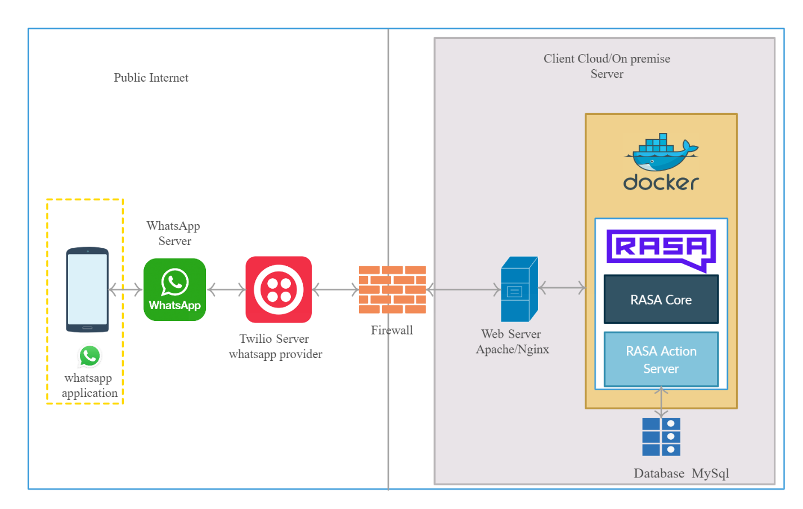

Proposed WhatsApp Chatbot to be designed& developed using RASA framework and Twilio API services. WhatsApp chatbot development requires components including Bot NLU & API services, hence our solution architecture is based on the RASA framework and Twilio services.

Following are the components of proposed solution

1. Twilio Services
2. RASA Framework
3. AWS /App Server

## Solution components overview

Following are the solution components in detail

### Twilio Api Services

Twilio Api services offers flexible integration b/w WhatsApp business api’s and trained RASA chatbot. Twilio framework offers quick deployment and testing of WhatsApp Bot services. Twilio is offering much more services like integration APIs for Messanger, Slack and Skype, Etc. Twilio has democratized communications channels like voice, text, chat, video, and email by virtualizing the world’s communications infrastructure through APIs.

### Whatsapp Business Account

WhatsApp is the most popular OTT app in many parts of the world. With the [WhatsApp Business API with Twilio](https://www.twilio.com/whatsapp), you can reach more than 1.5 billion WhatsApp users. Our Chatbot framework will [send notifications](https://www.twilio.com/docs/sms/whatsapp/api#sending-notifications), have [two-way conversations](https://www.twilio.com/docs/sms/whatsapp/api#conversational-messaging-on-whatsapp) to the customer.

WhatsApp uses your Facebook Business Manager account to identify your business and associate your phone numbers with it.

### RASA Framework

RASA framework will be the solution for our chatbot development. It’s an open source framework and Rasa provides infrastructure& tools necessary for high-performing, resilient, secured proprietary contextual assistants that work. RASA offers separate servers for the NLU training data and actions. There are APIs to store the activities & logs for the tracking management.

Rasa's NLU provides us with the technology to understand messages, determine intent, and capture key contextual information. Supports multiple languages, single and multiple intents, and both pre-trained and custom entities

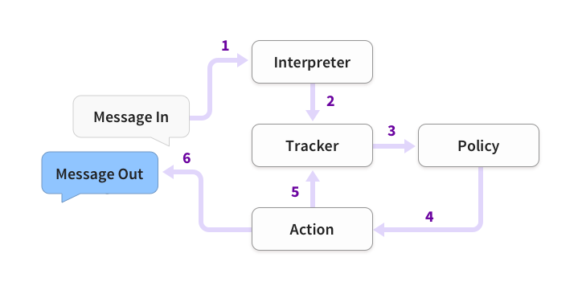

Following are the basic steps of how an assistant built with Rasa responds to a message:

1. The message is received and passed to an Interpreter, which converts it into a dictionary including the original text, the intent, and any entities that were found. This part is handled by NLU.
2. The Tracker is the object which keeps track of conversation state. It receives the info that a new message has come in.
3. The policy receives the current state of the tracker.
4. The policy chooses which action to take next.
5. The chosen action is logged by the tracker.
6. A response is sent to the user.

### Docker Containers

Docker is a set of [platform as a service](https://en.wikipedia.org/wiki/Platform_as_a_service) (PaaS) products that use [OS-level virtualization](https://en.wikipedia.org/wiki/OS-level_virtualization) to deliver software in packages called containers. Docker containers are isolated from one another and bundle their own software, [libraries](https://en.wikipedia.org/wiki/Library_(computing)) and configuration files, they can communicate with each other through well-defined channels. All containers are run by a single [operating system kernel](https://en.wikipedia.org/wiki/Kernel_(operating_system)) and therefore use fewer resources than [virtual machines](https://en.wikipedia.org/wiki/Virtual_machine).

The Rasa trained model and the Rasa Action servers will be deployed in the Docker container and will server ass different services.

Compose is a tool for defining and running multi-container Docker applications. With Compose, you use a YAML file to configure your application’s services

# Project Scope & Delivery

## Scope of Work

**Whatsapp Bot – For End users**

Whatsapp Bot will be developed using Rasa Framework and also using Whatsapp API’s from Twilio will also be used to set up the bot.

The following are the scope of work considered for the development for this phase.

* Implement WhatsApp bot with login functionality and various options for Policy users to select from and ger benefitted.
* Implement image to pdf conversion while submitting images for new claim.
* Fetch requested documents based on the options selected in the WhatsApp and accordingly download the same for the users.
* Implement the bot flow logic in RASA framework and implement the bot flow according to the flow document.
* Integrate API’s provided by Medscheme team for various functionality as agreed on the scope.

## Project Activities

Following are project related activities delivered as part of this proposal

|  |  |
| --- | --- |
| **Activities** | **Project Phases** |
|
| **Project Development** | **Requirement Gathering and project kick start** |
| **BOT Development and Whatsapp Integration** |
| **Facebook Business account creation and Twillio account for Whatsapp.** |
| **Development Bot & Server setup & Framework setup** |
| **BOT Workflow training** |
| **Api integration** |
| **Twiliointegration** |
| **WhatsappIntegration** |
| **Sanity Test & QA** |  |
|  |
| **QA Testing & issue fix** |
| **UAT** | **User acceptance Testing by Medscheme team** |
| **UAT movement & Issue resolution** |
|  |
| **Production** | **Production GO Live** |
| **2 Weeks of Post GO Live support** |
|  |

## Key Assumptions

The services offered, and costs are based on a set of reasonable assumptions. These are documented below

* We assume that customer/Medscheme team to assist Skien team in case of any clarifications.
* Medscheme team to provide necessary environments for all purposes such as development, UAT and production environment.
* This project to be delivered from offshore location. Remotely working resources to be provided access to the necessary Cloud accounts to effectively perform duties as outlined in this proposal
* The Medscheme team must provide us with Twilio user account to utilize WhatsApp Api for the bot development.
* They will also be responsible for obtaining Whatsapp business account by submitting various registration related documents and getting it approved. As informed earlier they must possess a Facebook business account as prerequisite to obtain the above.
* This proposal doesn’t cover any cost for preparing User Manual/Help documents.
* Customer to provide the End to End API’s for the entire development of the Bot.
* We assume that the domain and hosting will be provided by customer.
* Only Knowledge transfer training would be provided post Go-Live.
* SSL certificates to be procured and provide by customer.
* All the work will be entirely done at the SKEIN office, Coimbatore.  In case of any travel is required, the Customer is responsible for travel, accommodation, food, visa, and insurance

## Project Exclusions

* Procurement of any hardware or software required for this solution
* Issues/changes related to products or applications integrated with the solution
* Any functionality that is not mentioned in the In-Scope section
* Support beyond the warranty period
* Any product/Technology Training

## Project Estimates & delivery

Implementation services in this proposal will be provided on a fixed price basis.

This fixed price is exclusive of any travel and living expenses, other reasonable costs incurred in connection with out-of-scope services, and any applicable taxes.

The Services delivery will be provided as below,

|  |  |
| --- | --- |
| **Phases** | **Duration** |
| **Requirement Gathering and Project Setup** | 1 Week |
| **Whatsapp bot Development** | 6 Weeks |
| **UAT Testing and production movement** | 1 Week |
| **Warranty Support** | 2Weeks |

### 

## Project Deliverables

**At the end Phase 1 of the project:**

* Whatsapp Bot
* **Source code**
* Deployment of server code in the hosting environment

# Project scope Change Control Process

The following process will be followed if a change to this engagement is required if the Customer does not have a process to address such changes.

* A Project Change Request (PCR) will be the vehicle for communicating change. The PCR must describe the change, the rationale for the change and the effect the change will have on the project.
* The designated Program or Service Delivery Manager of the requesting party will review the proposed change and determine whether to submit the request to the other party.
* Both parties will review the proposed change and recommend it for further investigation or reject it. SKEIN will utilize existing Managed Services personnel for such investigation.
* The investigation will determine the effect that the implementation of the PCR will have on price, schedule and other terms and conditions of the Agreement.
* A written Change Authorization and/or PCR must be signed and dated by authorized representatives from both parties to authorize implementation of the investigated changes.
* Until a change is agreed in writing, both parties will continue to act in accordance with the latest agreement.

# Project Responsibilities

## Skein Responsibilities

SKEIN will on-board skilled resources to design, develop and deploy WhatsApp chat Bot

Below are the responsibilities,

* Requirement gathering.
* Implementation of the Bot using Rasa Framework
* **Design, develop and deploy backend serverusing Node.JS**.
* Integrate the Bot will Twilio API’s
* Unit Testing, QA Testing and support for UAT Testing.

## Medscheme Responsibility

Mr.Khaleel will be our SPOC for all Coordination’s and addressing all technical queries during the engagement. Following are the responsibilities expected from Medscheme team:

* Provide acceptance test criteria.
* Provide Test Data, hosting server

Participate in Review meetings and conference calls to review the progress of work and give concurrence on the functionality.

# **Commercials**

Following are the estimates commercials for delivering Design& development of mobile application.

|  |  |  |
| --- | --- | --- |
| **Phases** | **Delivery timeline** | **Cost (INR)** |
| **Whatsapp Bot Development Phase 1** | **10 weeks** |  |
| **Total** | |  |

**Note:**

The above cost is inclusive of

* Price mentioned in commercials section is exclusive of all Taxes.
* Payments are due net thirty (30) days from the date of the invoice.
* The pricing in this SOW is valid for fifteen (15) days.
* Price doesn’t include any software Licenses to be procured for this project.

## Payment Terms for Phase 1:

* **30% Down payment before start of milestone as advance**
* **30% upon partial completion of Whatsapp bot**
* **30% upon full completion of Whatsapp Bot and UAT Movement**
* **10% upon Completion of 4 weeks Warranty period**

## Software/accounts to be procured by customer

1. WhatsApp API
2. Twilio Account

## Twilio API Costing estimates

Twilio has a pricing model based on which it charges each conversation that takes place in the WhatsApp Bot. Kindly find below the pricing chart:

|  |  |  |  |  |  |  |  |  |
| --- | --- | --- | --- | --- | --- | --- | --- | --- |
| Sl No | Message Type | Whats app Per message Cost in India | Twilio Cost per message | Twilio Autopilot cost per message | Total Cost | Per 10K Messages USD | Per 10K Messages  INR | Comments |
| 1 | Template Message | $ 0.0042 | $ 0.0050 | $ 0.0010 | $ 0.0102 | $ 102.0000 | 7140 | Template messages: Outbound messages sent via Twilio that use one of the pre-approved templates. These are generally unsolicited transactional messages (delivery alerts, appointment reminders, etc.) sent to users who have opted in to receive messages from you |
| 2 | Session Message | $ - | $ 0.0050 | $ 0.0010 | $ 0.0060 | $ 60.0000 | 4200 | Session messages: All incoming messages, or outgoing replies to these messages within 24-hours. A messaging session starts when a user sends your application a message, and lasts for 24 hours from the most recently received message. Session messages do not need to follow a template, and can include media attachments. |

To use WhatsApp messaging in apps, you must enable WhatsApp on your Twilio number. WhatsApp is currently opening up this access in a *limited availability* program. This means that WhatsApp approval is required for all customers who wish to create their own profiles.